Atoms and Periodic Table Flash Cards
Back Side (Lined)
Front Side (Blank)
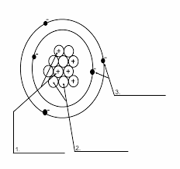 | 1. Parts of an atom:  1. protons  2. neutrons  3. Electrons
What are the charges of the three subatomic particles?  What keeps the atom together? | protons- positive  neutrons – no charge  electrons – negative charge  - Positive Proton is attracted to negative electron
What is an object that has all of the same atoms in it called? | An element
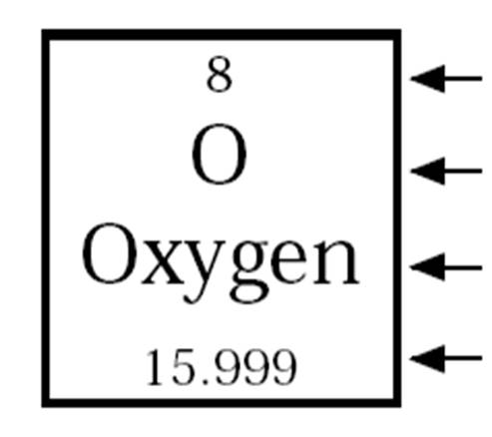  4  3  2  1 | 1. atomic number (Proton number)  2. symbol  3. Atom Name  4. Atomic Mass (Protons + Neutrons)
What is an isotope? | An atom that has a different amount of neutrons than protons.
How do I find the atomic mass of an object? | Protons + neutrons = atomic mass.  - To find subtract the number of protons from the atomic mass.
What are energy levels?  How many electrons are in the first three levels. | - Are areas around the nucleus that hold a certain number of electrons.  - 2, 8, 8
Rows on the periodic table are called what?  What do the elements in these rows have in common? | - Periods  - The have the same number of energy levels.
Colums on the periodic table are called what?  What do the elements in these groups have in common? | - Groups  - They have the same number of valence electrons.
What is a valence Electron? | - An electron in the outer most energy level.

